Informatica Activity:

DB:

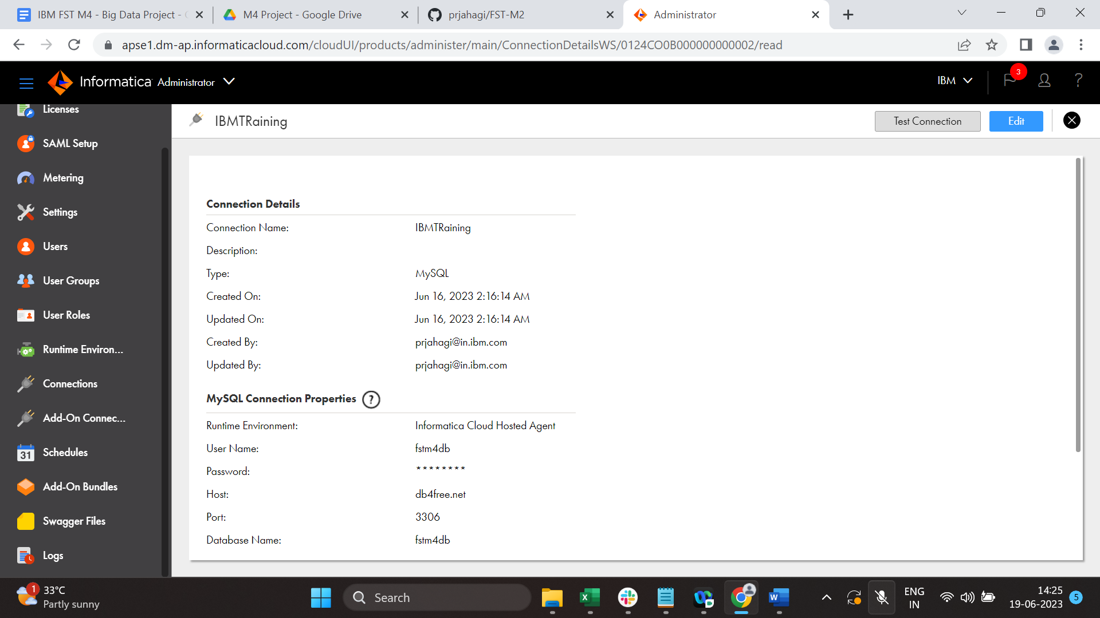

Source:

Target:

Filter:

My Jobs:

